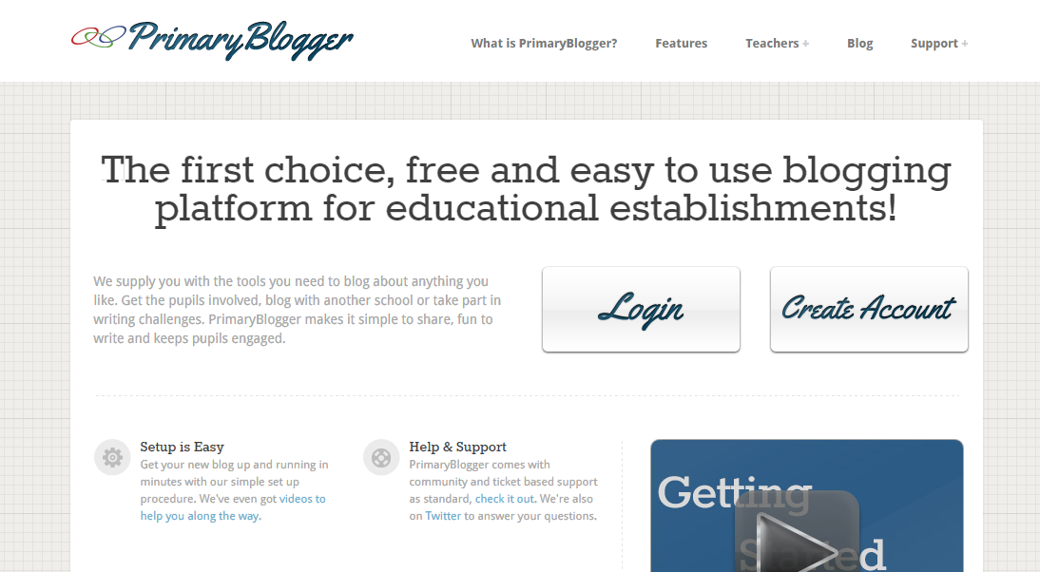
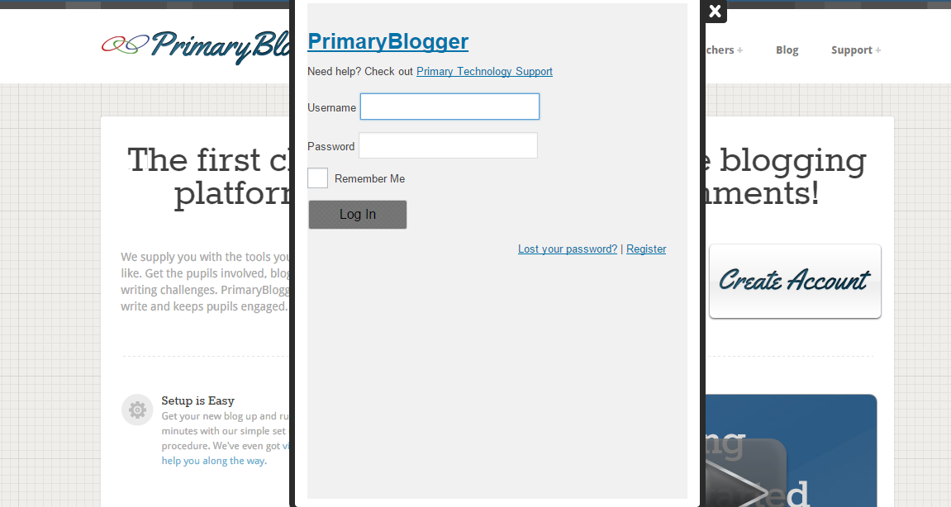
1. Go onto www.primaryblogger.co.uk
2. Click on login.
3. Type in your username and password. All usernames have been issued already.

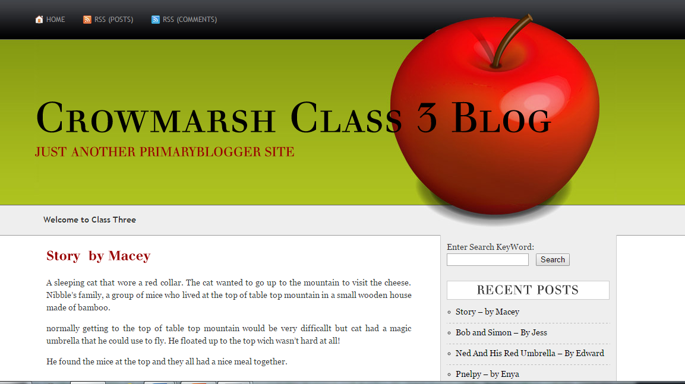
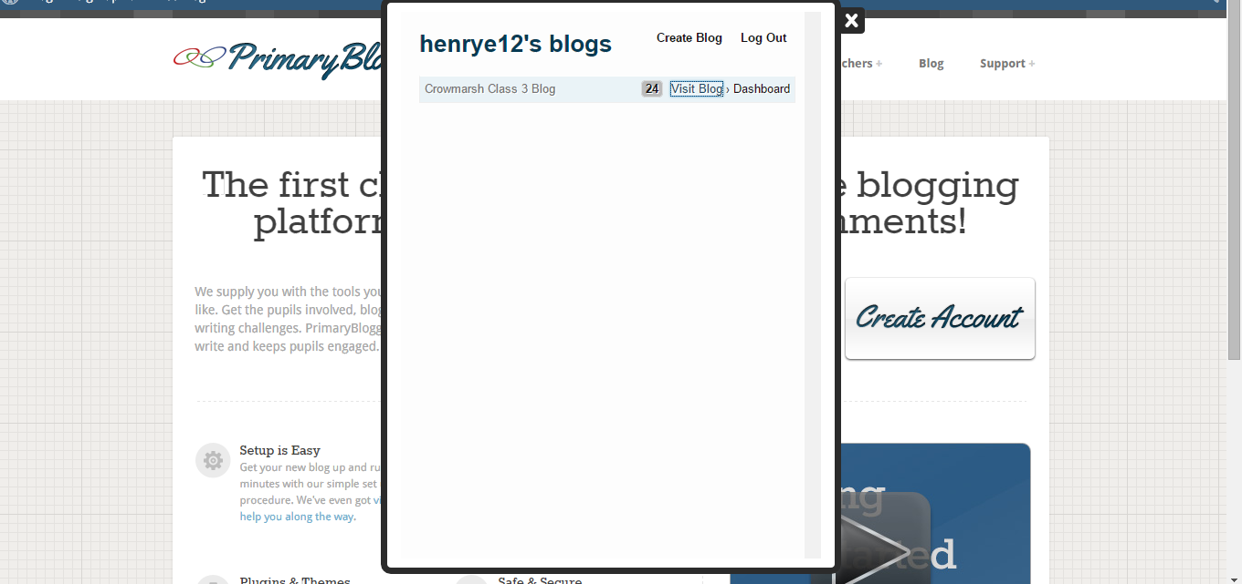
4. Click on visit blog.
5. You will now be on the Class 3 blog. You do not need to sign it to view this page but you will need to be logged in to comment.
6. If you can’t find the story you want to read remember to scroll to the very bottom of the page and click on previous entries. You can comment on any story or reply to comments you have received on your story.

