Class 1 Homework task 12/2/16
What I already know about dinosaurs:

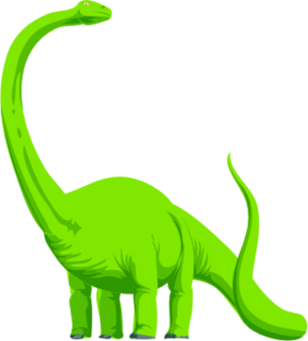
What I’d like to find out about dinosaurs:

