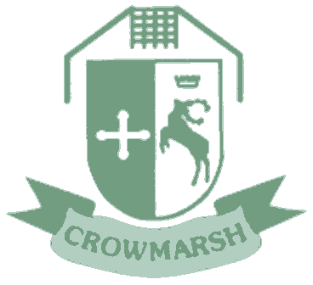
Deomcracy
- Democratic process evident in House System, School Council, all pupil leadership group elections, interviews, etc.
- Democracy themed collective worships
- Pupil Voice and democratic voting of key issues in school (e.g. school charity).
- Link with John Howell – Local MP
- Collaboration and participation in the Parliament 2015 Flags Project where we were chosen to represent Oxfordshire.
- Citizenship issues taught in PSHCE in upper Key Stage 2 and linked to learning about parliament and politics.
- Raised understanding of the UN and local and national politicians through our assemblies and weeks devoted to Send My Friend Campaign and the Global Goals.
British Values at Crowmarsh Gifford Primary School
Mutual Respect
- SEAL taught as our PSHCE curriculum across the school which teaches children about respect and other key issues about being a fruitful 21st citizen of modern Britain
- Equality Policy
- P4C used across school as a way to get children to think about ‘Big Question’
- Impeccable manners and modelling of respect expected by all members of our community
- Anti-Bullying Week
- Focus on Anti-Bullying issues by school council
- Sporting competitions across school partnerships and nationally – we are always highly commended on our sportsmanship
- Buddies and Peer Mentoring – Leadership Groups
- Focus on ‘character education’
Rule of Law
- Behaviour Policy
- House Points, Learner of the Week, Headteacher Values Award
- Buddies and Peer Mentoring – Leadership Groups
- Eco-Council – monitor energy consumption
- UNICEF 21 Assemblies and Rights Education
- Links with local police – come in to discuss key issues (Halloween, Firework Safety, Road Safety, etc)
- House System, School Council and Leadership Groups
- Teaching of Law through SEAL/PSHCE curriculum
- Children have a very mature understanding of right and wrong and we talk about ‘Being a Leader and Not a Follower’ especially when it is the difficult thing to do.
Tolerance of Different Faiths and Beliefs
- Oxford Diocese RE Curriculum implemented
- Equality Policy, Behaviour Policy and Accessibility Plan
- UNICEF 21 Assemblies – Focus on key dates (e.g. Martin Luther King Day, Holocaust Memorial, Human Right’s Day, World Refugee Day, etc)
- Celebration of English, German and French traditions among others
- Multicultural Weeks and Links with Masekane School in South Africa
- Celebration of key church festivals
- Celebration and focus on key religious/cultural festivals (e.g. Chinese New Year, Eid, Hanukkah, etc.)
- Local church leaders regularly take collective worship as well as visits to local places of worship
- Participation in ‘Prayer Spaces’ in our school to get children to reflect on others and of global issues
Personal Responsibility and Liberty
- Pupil Leadership Groups
- Responsibility is a core school value – therefore is used as basis for many collective worship sessions and general discussions around school
- Learner of the Week Certificate, Headteacher’s Value Award
- Values integral to our school and constantly referred to
- Home School Agreements
- Focus on independent and ‘responsible’ learners
- A focus on responsibility as learners and as members of our community
- Key issues of responsibility and liberty major focus of UNICEF 21 Assemblies throughout the year
- Internet Acceptable Use Agreement – Class Charters
- Focus on UN Convention of Rights (Their rights and the rights of others)

